ForgeAI Project
Project Website: https://app-builder-5s7g.vercel.app
Project GitHub: Akshay23-source/App-Builder

Project Screenshots
Screenshot 1
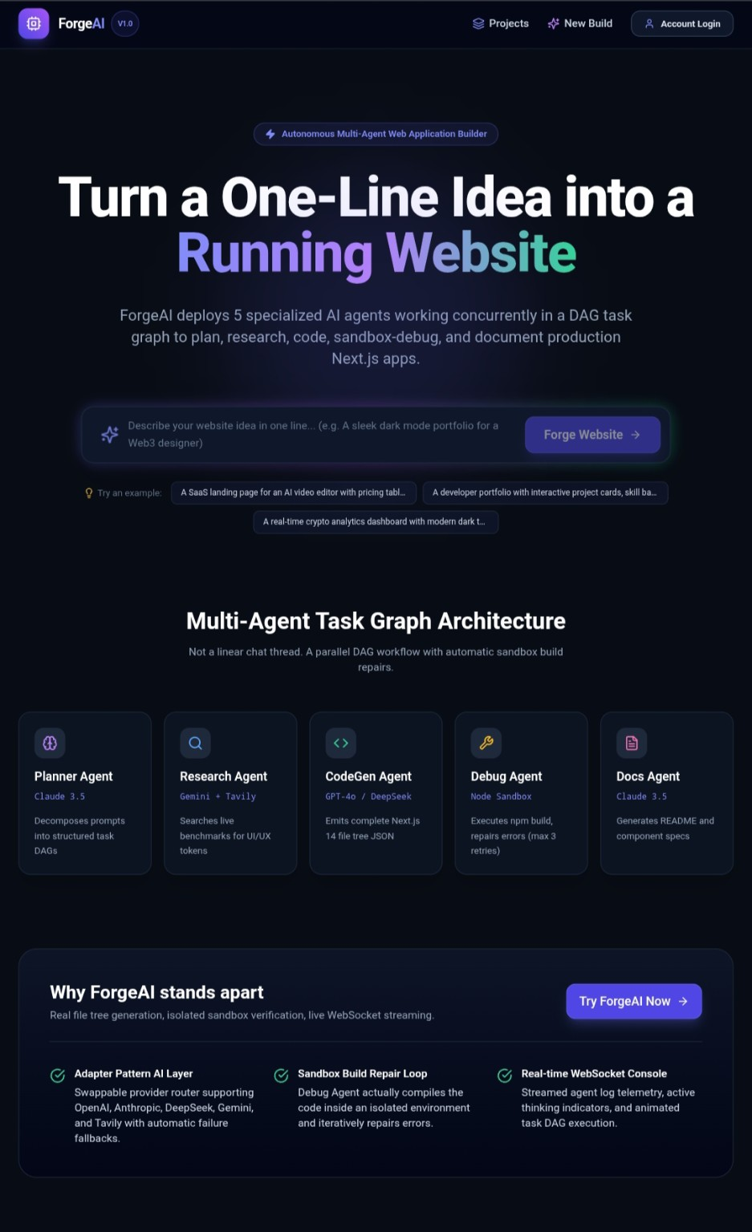
Screenshot 2
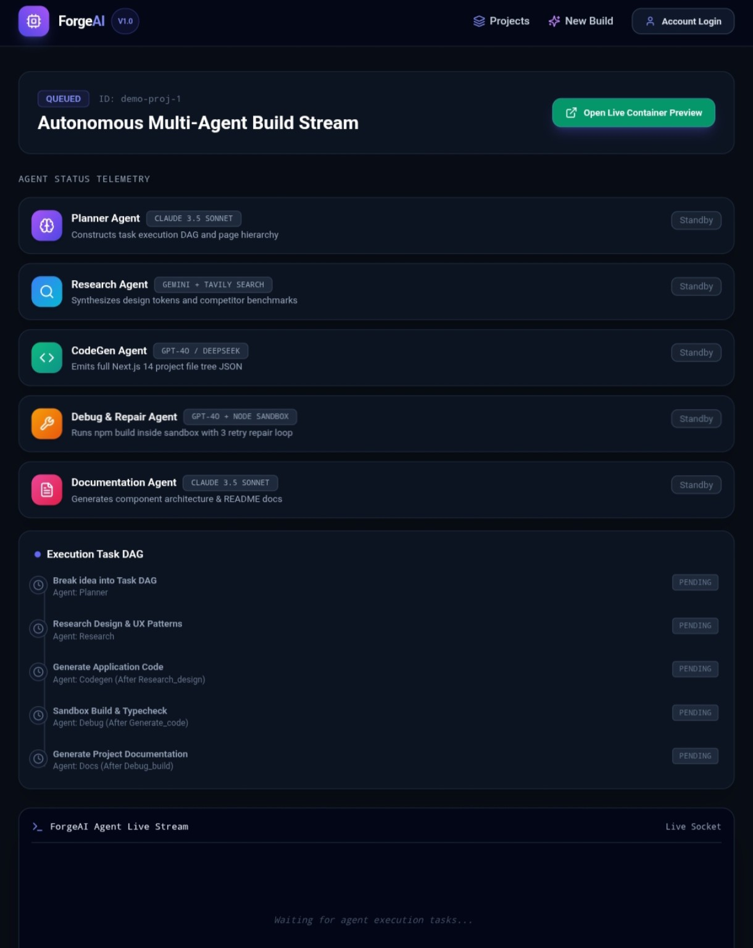
Screenshot 3
